Event bubbling & capturing
Event bubbling and capturing are two phases of event propagation in the DOM (Document Object Model) that determine the order in which event handlers are executed. Understanding these concepts is crucial for effective event handling in JavaScript.

Event Propagation Phases

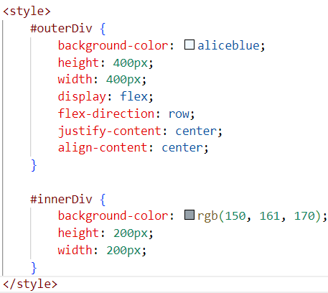
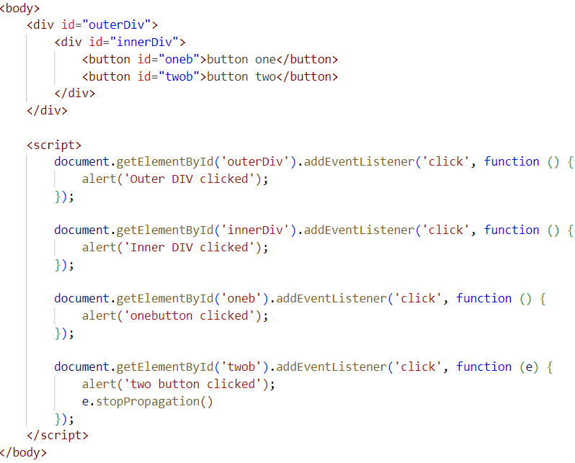

1. Event Bubbling
Event bubbling is the process where an event starts from the target element and bubbles up to the root of the DOM tree. In this phase, the event is first captured and handled by the innermost element and then propagated to the outer elements.
e.stopPropogatoin() will help to stop the bubbling it self stop the bubbling and won't allow to the root direction
—-----------------------------------

Event Capturing (Trickling)
Event capturing is the phase where an event starts from the root of the DOM tree and trickles down to the target element. In this phase, the event is first captured and handled by the outermost element and then propagated to the inner elements.
<div id="outerDiv">
<div id="innerDiv">
Click me
</div>
</div>

<script>
document.getElementById('outerDiv').addEventListener('click', function() {
console.log('Outer DIV clicked');
}, true);

document.getElementById('innerDiv').addEventListener('click', function() {
console.log('Inner DIV clicked');
}, true);
</script>

Outer DIV clicked
Inner DIV clicked

